Christmas Fun

Team members: Bogdan George-Alexandru, Mandici Rahela, Popa Stefan-Dorin, Radeanu Dragos-Nicolae

Similar products & Relevant Links(>=3)

**Name: Snapchat**

**Url: https://www.snapchat.com/**

**Relevant Features**

* Christmas Face Filters
* Share photos on social media
* Record with face filters
* Interactive games
* Create your filter

**Name: FaceArt Selfie Camera**

**Url: https://play.google.com/store/apps/details?id=com.lyrebirdstudio.colorizer.lite**

**Relevant Features**

* Pic Collage Maker
* Background static/dynamic
* Share photos on social media

**Name: Instagram**

**Url: https://www.instagram.com/**

**Relevant Features**

* Boomerang
* Layout
* Share photos

-------------------------------------------------------------------------------------

Main Features

1. Take photos with face filters
2. Record with face filters
3. Play interactive games
4. Share photos on social media
5. Make collage
6. Import face filters

Script / User Journey

1. Search face filters
2. Download package filter
3. Take photos/videos
4. Make layout/collage
5. Share on social media
6. Save photos/videos

Moodboard

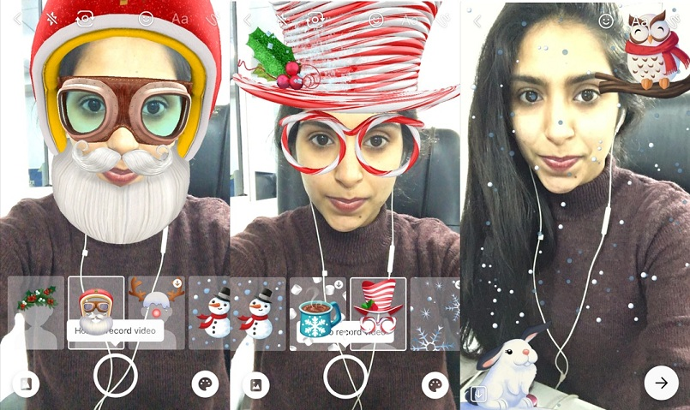

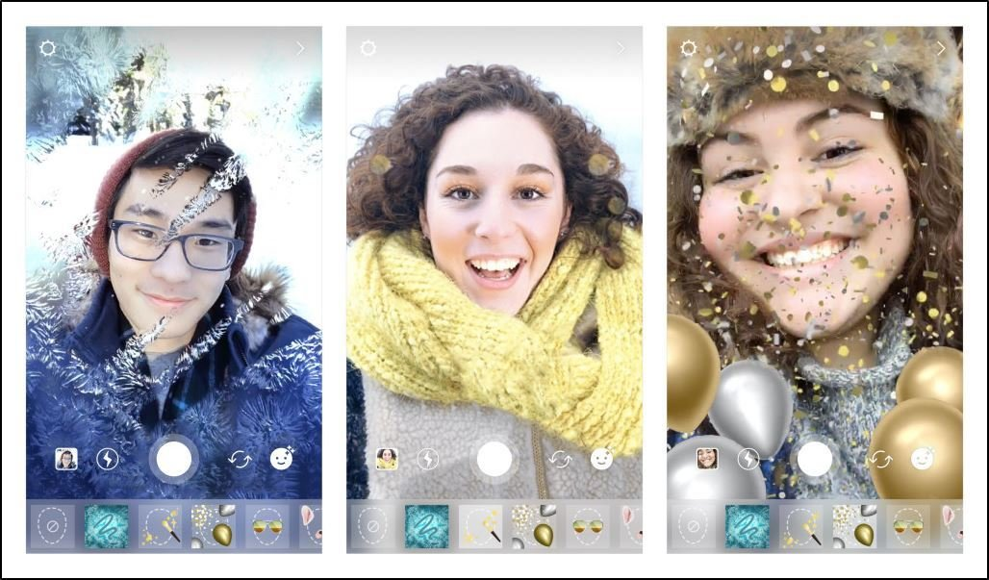



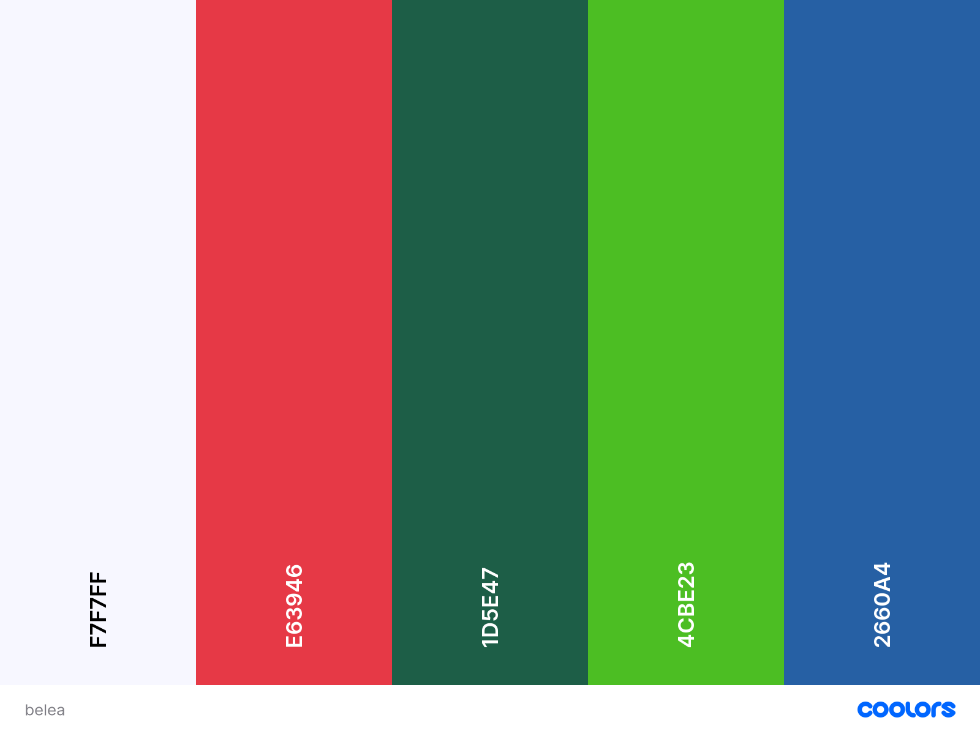

-------------------------------------------------------------------------------------

Technical Components

1. Cloud for storing face filters
2. API - share photos
3. API - download face filters
4. Phone Camera

Technologies, Libraries, Assets (>=5)

1. Unity
2. Android Studio
3. Unity ARFoundation
4. Heroku
5. MongoDB
6. NodeJS
7. Blender

Relevant links:

<https://developers.google.com/ar/develop/unity/augmented-faces/developer-guide>

<https://www.c-sharpcorner.com/article/building-a-simple-arcore-demo-with-augmented-faces/>

<https://www.youtube.com/watch?v=y0L_AdJICEU&ab_channel=DineshPunni>

<https://www.youtube.com/watch?v=RDoPr0rT6ps&t=196s&ab_channel=ColorfulCoding>